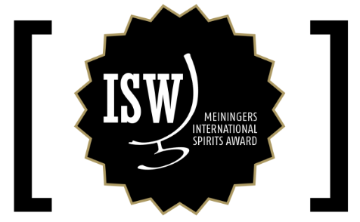

Press release
Neustadt, 28. January 2021

Successful start of the new monthly format / Best wine and grape marc spirits awarded / Asbach 21 years top class again

Meininger's International Spirits Award (ISW), one of the oldest and most renowned spirits competitions, has opened a new chapter in its success story with the start of 2021. Unlike in the past, the ISW now relies on a monthly rotation in which it specifically focuses on individual spirits categories (e.g. gin, whisk(e)y, rum). Thanks to the new format, winning products can now be marketed in a very targeted and precise manner.

The best that can be made from grapes was put to the test at the start in January: national and international wine and grape marc spirits. A top-class jury of spirits experts, distillers, bar professionals and other luminaries from research and teaching tasted the distillates according to the special scheme of the Meininger’s International Spirits Award, in which the products are not only evaluated but also decisively described in sensory terms.

The spirits experts chose the Asbach Selection 21 Years Matured as the "German Brandy of the Year 2021". The traditional distillery from Rüdesheim thus not only defended its title from the previous year, but once again highlighted the great class of German brandies that can compete with international rivals at the top level.

The special prize "Cognac of the Year 2021" was won by Maison Frapin. With its outstanding Château Fontpinot XO Premier Cru Cognac Grande Champagne AOC, which is produced from the vine to the bottle in the castle of the same name, the company, whose roots go back to 1270, convinced the jury across the board.

The jury chose the Brandy de Jerez Solera Gran Reserva from Bodega Emilio Lustau as "Brandy of the Year 2021". The house, which is primarily known for excellent sherries, thus also impressively proves its expertise in brandy and sets a real benchmark in this segment.

There is also another reason to celebrate in Piobesi D'Alba, Italy - the home of Distilleria Sibona. Last year it already won the award for "Grape Marc Spirit of the Year 2021" and with the Sibona Grappa di Barolo Invecchiata 2007 it has achieved this feat again. Another well-deserved accolade for a true grappa institution.

"It was a perfect start," says Christian Wolf, Director Degustation of ISW. "The feedback from the industry shows us that we have taken the right path with the new format." Alexander Thürer, board member of the Spirits Award, adds: "The focus on individual spirits categories per tasting helps to deal even more intensively with the peculiarities of the individual distillates and sharpens the view of our jury even more."

The next themed tasting will take place in mid-February. Then the world of liqueurs will be on the agenda.

An overview of all medal winners of the January tasting can be found here: www.meininger.de/en/isw/results

About Meininger's International Spirits Award ISW
The international spirits competition was launched 18 years ago by Meininger Verlag. Until 2020, spirits experts from all over the world gathered once a year in Neustadt an der Weinstraße to taste and evaluate spirits of all kinds from all over the world. With the new orientation towards a monthly, theme-specific tasting format, the competition guarantees an even more detailed tasting and assessment of the submitted spirits by a proven jury of experts, now focusing specifically on special spirits categories.

Meininger's International Spirits Award ISW is one of the most important spirits competitions in the world today. With its tasting methodology, the competition sets new standards in the field of spirits evaluation. Based on the international 100-point scheme, the spirits are not evaluated comparatively, but individually according to appearance, smell and taste by a jury of experts without knowledge of the producer. In addition, the competition describes each tasted spirit sensorially in terms of the aromas and attributes typical of the respective competition category. From this, an aroma diagram is created that is comprehensible and understandable for distillers and consumers and gives a first impression of the flavour of the spirit.

Founded in 1903 in Neustadt an der Weinstraße, Meininger Verlag is one of the oldest German specialist publishers. The company specialises in particular in the wine and spirits sector. Internationally, Meininger Verlag has made a successful name for itself with the MUNDUS VINI Grand International Wine Award. In addition to well-known trade magazines, the media company organises trade fairs, industry events and trade congresses. The portfolio of Meininger Verlag also includes FINEST SPIRITS in Munich, the trade fair for premium spirits with an international festival character.

Pressekontakt:
Nicole Zeisset
Meininger Verlag GmbH
Maximilianstr. 7-17
67433 Neustadt
Tel.: 06321 89 08 94
E-Mail: zeisset@meininger.de
Internet: www.spirits-award.com

